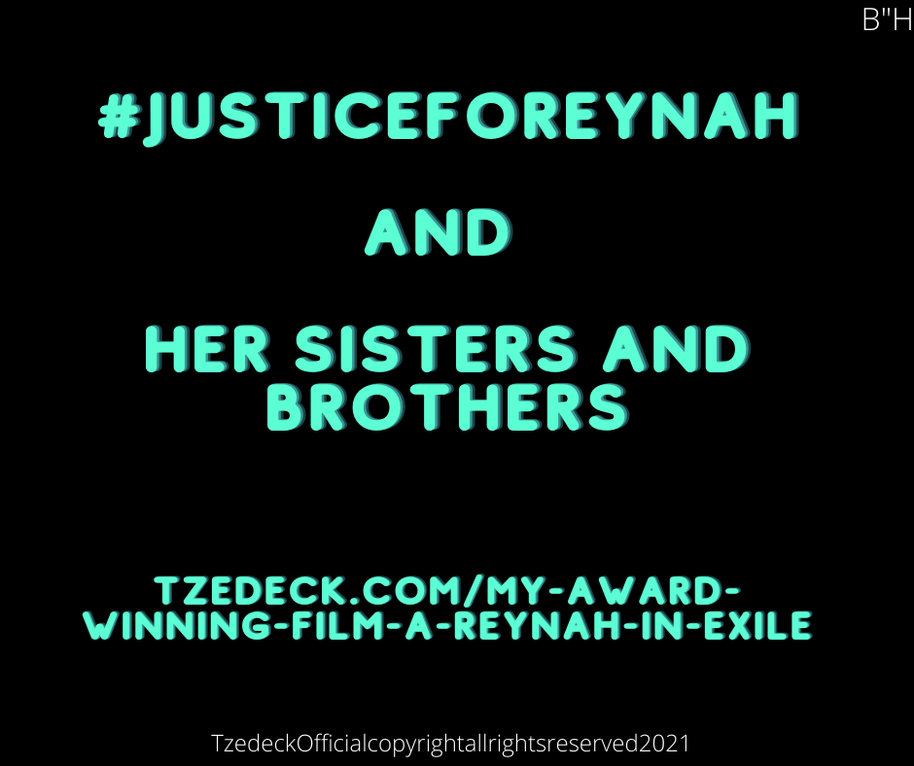

With the help of the heavens
B”H
The Gateway to Freedom Kit®

Written by:

Hadassah Chavivah bat Chayah Faigah Zeltzer

#QueenEstherOneDollarFund

Tzedeck.com

Tzedeck
Jewelry®

https://www.youtube.com/@HadassahChavivahZeltzer

https://www.pinterest.com/Tzedeck/

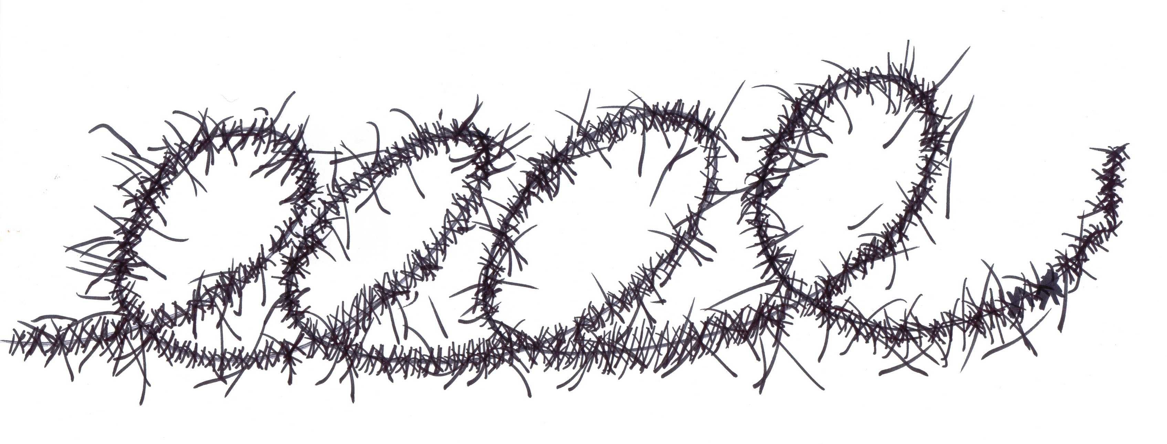

Cover of the booklet says the following:

This is a spiritual, inclusive kit. If you don’t believe in G-d, adapt these tools to your own personal belief system and your own way of finding inner strength.

First Page:

The Teaching that is engraved on your bracelet is taken from a Hebrew text from the our morning prayer service called Shacharit in the Jewish Siddur.

( Siddur means Prayer book in Hebrew)

The literal translation of the Hebrew text is

THANK YOU, G-D, FOR NOT MAKING ME A SLAVE

Sometimes tragically in life a person will find themselves a slave.

Both by outer and inner forces that will keep them from having a life worth living.

The message on our bracelet is very simple

We were born to be free.

If you find yourself in bondage in any particular area of your life you should not despair.

Take courage and know that all freedom comes from knowing that there is only one true source.

Giving away your power to any other source besides this one true source will keep you in bondage in all areas of your life. The bracelet’s message is humble yet powerful.

Once you can understand this principal with all your, heart, mind, and soul you will be set free.

Here are several different ideas to make the most out of The Gateway to Freedom Kit. Feel free to use any of these suggestions or choose a method of your own that will bring the most meaning form the product.

Wear this bracelet at all times as a reminder of who you are (Royalty) and you were born to be free.

Use the bracelet as an anchor to calm yourself down when you find yourself feeling overwhelmed or anxious about a situation in your life.

Do your best to really believe you were born powerful enough to overcome the challenges in your life.

Take a few seconds to pause and look down at the Hebrew or English text that is engraved on your bracelet.

Meditate on the words and its message to gain strength from their meaning.

Say them to yourself like affirmations until you start to feel calmer or that you’re not alone.

If you don’t read Hebrew, You can use the word “Royalty” or a word of your choosing that empowers you to feel hopeful and strong.

This way you will associate the Hebrew with a word that gives your courage and strength when you look at the bracelet.

THANK YOU, G-D, FOR NOT MAKING ME A SLAVE.

“Hashem is with me I shall not Fear”

Meditate on the meaning of the words and become aware of how those words make you feel. (Resilient, powerful, worthy, deserving etc.)

This Partial text was taken from our
Copyrighted and Trademarked product
The Gateway to Freedom Kit

Please Feel free to download this document for Free!

Happy Holidays!
Merry Christmas!
Happy Kwanzaa!

#Pleasebringthemhomenow

May we all merit the war to end soon.

Tzedeck.com

#QueenEstherOneDollarFund

Tzedeckmusiccopyrightallrightsreserved2024

Copyright Infringement will be prosecuted.

